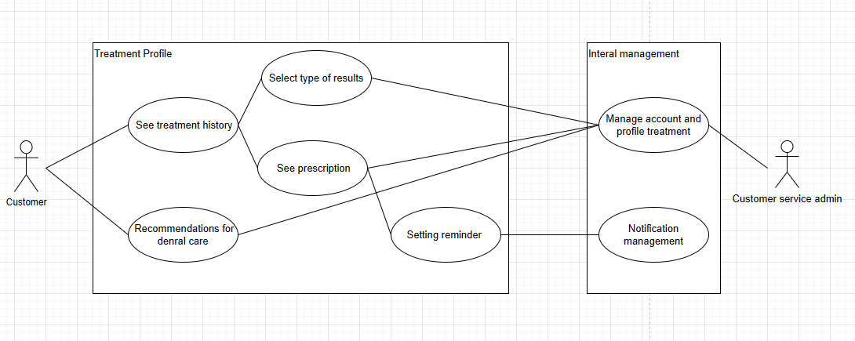

|  |  |
| --- | --- |
| **UC Name** | See treatment history |
| **Actor** | Customers, Customer service admin |
| **Decription** | As a customer, I want to know the results of my medical exams |
| **Priority** | High |
| **Trigger** | Customer clicks “Treatment history” button |
| **Pre-condition** | 1. Customer has logged in personal account. 2. The patient’s medical history has been updated on the system |
| **Basic flow** | 1. Customer clicks “treatment history” button 2. Customers choose the type of viewing time. 3. Customers select the button “examination results” to see specific results of an examination. 4. Customers choose the type to view medical examination results. 5. The system returns the results that the customer wants to see. 6. Customer views the examination results |
| **Alternative flow** | 2a. Customers choose to view medical history by month.  *Use Case continue at step 3.*  2b. Customers choose to view medical history by year.  *Use Case continue at step 3.*  2c. Customers choose to see all medical history.  *Use Case continue at step 3.*  4a. Customers choose to see test results.  *Use Case continue at step 5.*  4b. Customers choose to see image results.  *Use Case continue at step 5.* |
| **Exception flow** |  |
| **Business rule** |  |
| **Non-Function**  **Requirements** |  |

**Activity Diagram:**

